Name: Due: Classroom Day 7
Choose the vehicle you will most likely be driving, if available. For Parts A and B, take photos, label and print. For Part C, discuss with the vehicle driver and/or check owner’s manual and write the answers on this sheet. Attach this sheet to your completed Parts A and B, or turn this sheet in alone if you email your assignment to the instructor
Instructor email address:______________________________________________________________
Year, make and model of vehicle: ________________________
A. Under the Hood

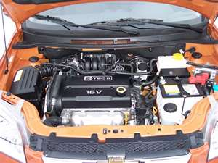 | - Engine Oil dipstick  - Transmission Fluid dipstick  - Brake Fluid reservoir (Master Cylinder)  - Battery (here or elsewhere in the car)  - Air Filter Assembly | - Engine Antifreeze/Coolant reservoir  - Windshield Washer Fluid reservoir  - Power Steering Fluid reservoir (if equipped)  - Drive Belts  - Engine Oil Filler cap

B. Interior/Dashboard
Circle Airbag Locations:
Driver front Passenger Front Side Torso Side Head Protection or Side Curtain Knee

How does your head restraint adjust? ________________________________________________
________________________________________________________________________________

Additional Safety Equipment/Features________________________________________________
________________________________________________________________________________

Circle type of tire failure equipment:
Full Size Spare Tire “Donut” Spare Tire Fill/Repair Canister

Do you have Jumper Cables in your vehicle? Yes No

Where is your insurance card located?________________________________________________

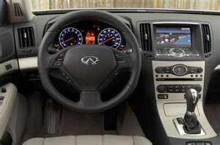 | - Horn  - Speedometer  - Tachometer (if equipped)  - Gear Shifter  - Gear Selection Indicator  - Brake Pedal  - Accelerator Pedal  - Emergency/Parking Brake  - Fuel Gauge  - Odometer | - Turn Signal Switch  - Heat/Defroster/AC Controls  - Windshield Washer/Wiper Switch  - Hazard Lights Switch  - Engine Temperature Gauge/Light  - Airbag Light  - Safety Belt Light  - Battery Voltage Warning Light/ Gauge  - Service Engine Light  - ABS Light

C. Safety Equipment

